**ICT TECHNICIAN LEVEL 5**

**IT/OS/ICT/CR/3/5**

## **PERFORM COMPUTER REPAIR AND MAINTENANCE**

**MAY 2024**

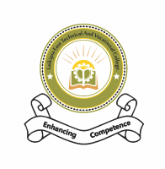

**LAIKIPIA EAST TECHNICAL AND Vocational COLLEGE**

**PRACTICAL ASSESSMENT**

**1 Hour**

**INSTRUCTIONS TO CANDIDATE**

1. Time allocation: **15 minutes** for preparation and **1 Hour** for performing tasks.
2. Read the instruction manuals from the manufacturer or configuration of some parts.
3. In this practical assessment you are required to perform the following two tasks:
4. **Assemble a computer system from the equipment/devices provided.**
5. **Test the computer to ensure its ready for software installation.**

You are provided with the following resources to carry out the tasks:

* + Processor (CPU)
  + Computer Case
  + Optical Drive (DVD RW and SATA capable)
  + Memory (RAM)
  + Power Supply
  + SATA Cables
  + Motherboard (SATA Capable)
  + Processor Fan
  + Case Fan
  + Hard Drive (SATA Capable)
  + Heat sink compound

You will also be provided with the following tools in a toolbox.

* Screwdrivers
* Small container to hold screws

**THIS IS THE LAST PRINTED PAGE**